Peter Stastny

**Game name:**

Cheese Rush

**Asset list link**

<http://www.psdesigns.eu/module-04/asset-list/assets.html>

**Design documentation**

The backstory of the game consists of helping a mouse catch cheese. To do so, you have to click on it as it falls down the screen while avoiding bad objects.

**Mood board**

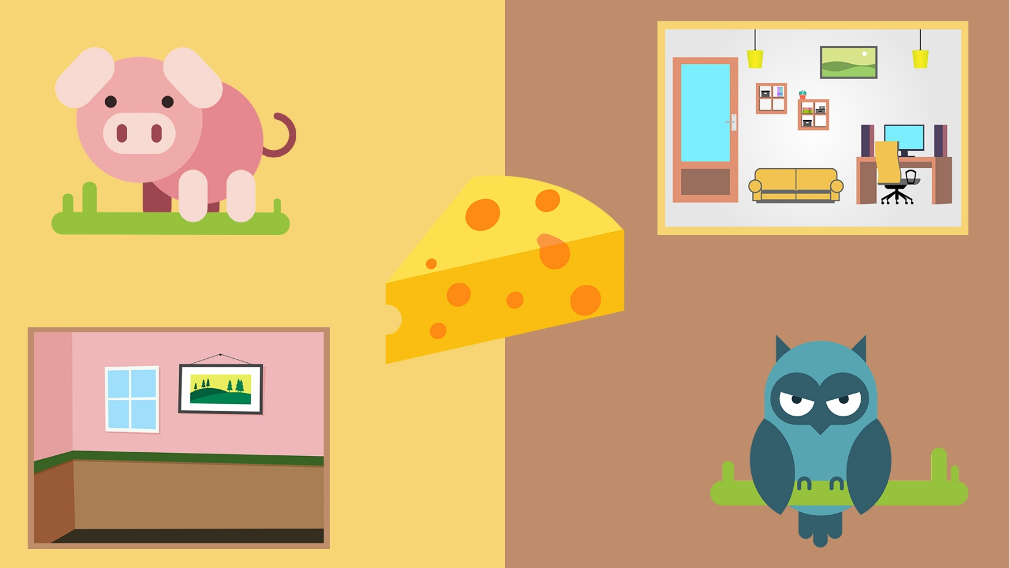

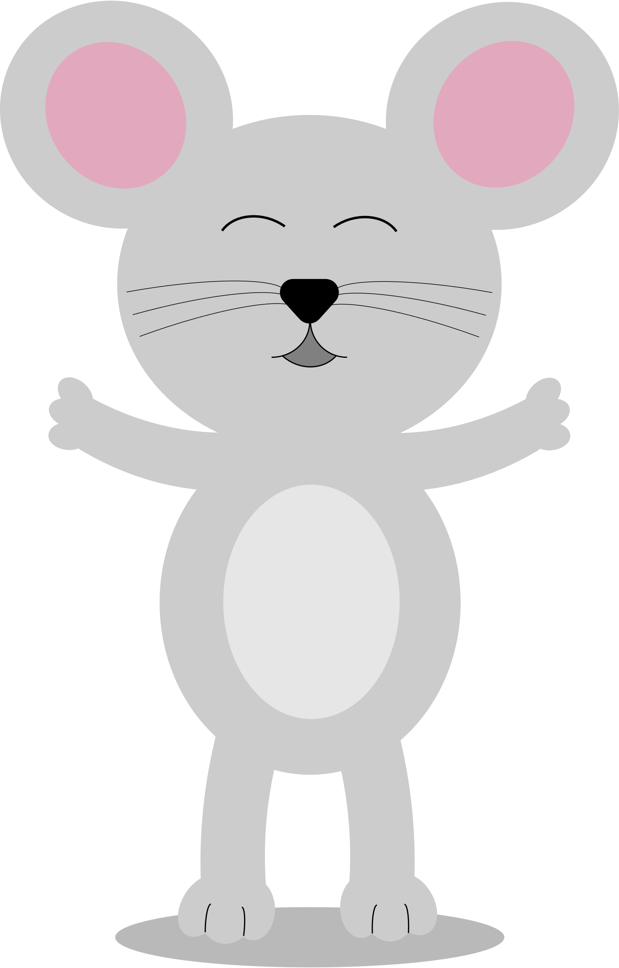

I used basic shapes like ellipses, rectangles, and tringles throughout the whole design. I was often adjusting and combining them and working with various tools when I needed to make a more complex shape or object.

Apart from shapes, I was also using lines or drawing with the brush tool and adjusting them further when I wasn’t sure how to make a shape I wanted.

**Style tile**

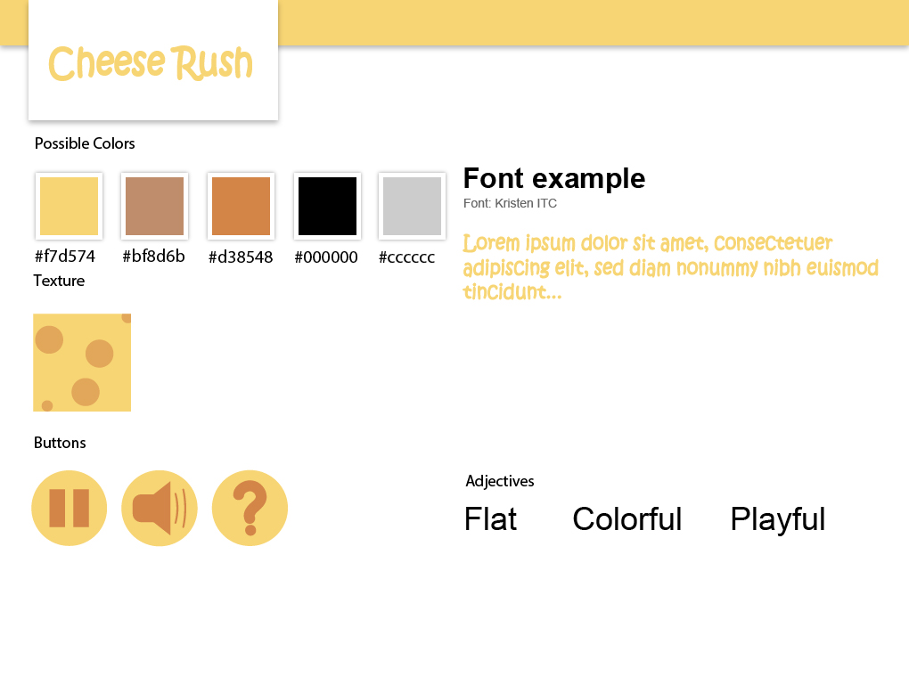

As far as the UI elements go, for the score I chose to display a cheese sprite followed by a colon and a number of points gained slash a number of points required to win. The lives, represented by hearts would be in a line near the score, as would be the case for time. The time would be simply a word, followed by a colon and a number of seconds remaining.

**Early sketches**

